Agenda of Today’s Meeting (25th-February’25)

Key points to be discussed:

- Manage Devices:
- Currently, we have considered the following fields for both Camera and AI Box, based on the existing application and what was showcased during our previous meeting. Please let us know if any changes are required.
- When adding a new device using an AI Box, should we display:
  - A single entry for the AI Box, or
  - Separate entries for all associated cameras in the device list?
- Additionally, we need clarification on the following points:
  - Device Configuration Form: Confirmation on the required fields and their validation.
  - Figma Design Review: The SPEC Team will demonstrate the prepared Figma design for this during our meeting.
  - Live Preview: Where should the live preview be displayed?
  - Data Replication: When should we start replicating data from the camera?
  - Field Usage: What is the exact purpose of the following fields while configuring the device?
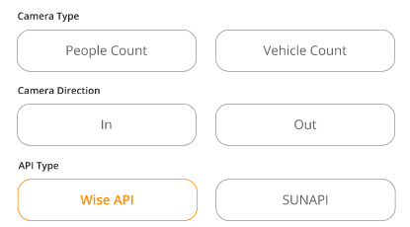

- API Integrations:
- I have attached an XLS file named "List of Features for API Integrations.xlsx" in the email, which contains the list of features and functionalities that require API calls to fetch or modify information.

- I need your assistance in identifying the exact API endpoints that should be utilized for the mentioned features and functionalities. Please gather the necessary details from the respective person(s) and provide the information as soon as possible, as it is crucial for us to proceed with the next steps of API integration.

- Map Plan MGMT:
- We have reviewed the references you shared for Map Plan integration over the email earlier and found that the provided libraries/references offer different types of features. Some of these features are not feasible to implement using free or open-source libraries.

- Additionally, we need further clarification regarding the exact features and functionalities you want to implement in the Map Plan. As I already requested you earlier, kindly provide a detailed list of the specific/ concrete features you require. This will help us conduct further research and development to explore viable solutions using open-source or free libraries.

- Floor Plan MGMT:
- We are still checking the feasibility of previewing .dwg, .svg, and .pdf files with zoom-in and zoom-out functionality.
- Additionally, we are evaluating support for a 10MB file size limit.
- The SPEC team will get back to you once the feasibility check is complete.

- Need clarity on “API details for Solar pole integration” shared over email on Tue 18-02-2025 3.38 PM.

Pending Items for Bala & Team:

- Source Code Access: When do you anticipate providing the source code for both existing applications?
- Additional Camera Link & AI Box: When can we expect an additional camera link for online testing, including the AI box? This will help us test the camera API responses.
- Installation of existing application on your test PC (which is prepared by SPEC Team).
- Sample file for License from the existing application for the SPEC’s reference.
- List of Functionalities to be implemented in the Map Plan.
- The logo, font & color combinations for our BI Dashboard Application.
- Physical Camera Devices – SPEC Team will receive it by next Wednesday (19th-Feb’25) or Thursday (20th-Feb’25).
- Meta Data related information for API Integration.
- Sample Collection for camera APIs.
- Understanding on Camera Data replication from real-time configured camera.

